12. FLOW OVER SUBMERGED BODIES
- When a fluid flows and passes the submerged body with a relative velocity ($U_{∞}$), every differential surface area experiences a pair of forces due to Pressure & Wall shear stress$(τ_{0})$.
- Therefore, the body observes a net resultant force, which has 2 components,
  - Drag Force: Along the axis of $U_{∞}$
  - Lift Force: Perpendicular to the direction of $U_{∞}$
$$dF_{D}=τ_{0}dA\cos{θ}+PdA\sin{θ}$$ | $τ_{0}dA\cos{θ}$= Shear or Friction Drag | $PdA\sin{θ}=$ Pressure Drag

CLASSIFICATION OF BODY
STREAMLINE BODY | BLUFF BODY
A body whose surface coincides with the streamlines of flow. | A body Which obstructs the streamlines of flow is known as bluff or blunt body.
Pressure Drag is very low & total drag is also less. | Relatively Higher Pressure Drag & Total Drag is high.
Boundary layer separation is low. Hence, lesser eddies and subsequent losses. | Boundary layer separation is high. Hence, Higher eddies and subsequent losses.
E.g. Fishes Shape, Aerofoil, Hydrofoils, etc… | E.g. Cylinders, etc…
DRAG FORCE:
$$F_{D}=C_{D}A_{ch}\frac{1}{2}ρU_{∞}^{2}$$ | $C_{D}=$Coefficinet of Drag$=f(Re, Geometry,Ma (For compressible flow))$  $A_{ch}=$ Characteristic area
$$A_{ch}=A_{Proj}(For Blunt Body)$$ |  | $$A_{ch}=A_{Plan}(For Streamline Body)$$
POWER LOST DUE TO DRAG:$P_{D}=F_{D}U_{∞}$
$F_{D}$ mostly acting in the direction opposite to desired motion of the body.
LIFT FORCE:
$$F_{L}=C_{L}A_{Plan}\frac{1}{2}ρU_{∞}^{2}$$ | $C_{D}=$Coefficinet of Lift$=f(Re, Geometry,Ma (For compressible flow))$  $A_{Plan}=$ Plan area
Note: If effective area is mentioned, then replace $A_{Plan}\&A_{Proj}$ With $A_{eff.}$
DRAG ON SPHERES:  - ${Pressure Drag}/{Shear Drag}=0.5$  - If $Re≤1$, the flow is known as Stokes Flow. And Stokes Law is valid. | STOKES LAW: $F_{D}=3πμDU_{∞}$  For Stokes Law, $C_{D}={24}/{Re}$  $$∵A_{ch}={πD^{2}}/4 \& Re≤1$$
Q. Obtain Terminal Velocity of a sphere falling(down) under gravity in a dense and viscous fluid. Assume stokes law is valid.  At equilibrium Condition, $W=F_{B}+F_{D}⇒U_{∞}={\left(γ_{b}-γ_{f}\right)D^{2}}/{\left(18μ\right)}$ | TERMINAL VELOCITY:  The constant Velocity obtained by a body when it reaches equilibrium.
DRAGS ON CYLINDERS:
When the $Re≥45$, The vortices in the region of wake become highly unstable loading to shading of vortices. This phenomenon is referred as “Karman Vortex Trails” (Shown in fig.). |  | 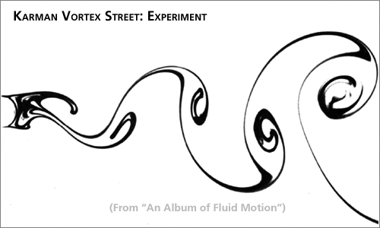
Frequency of vortex Shading$=n$ | $$Strouhal Number=\frac{nD}{U_{∞}}=0.198\left(1-\frac{19.7}{Re}\right)$$
If the Frequency of vortex shading matches with the natural frequency of cylinder, then resonance takes place. Due to resonance a sound is developed & it’s known as singing of wires.
MAGNUS EFFECT: The lifting effect generated on rotating body when it’s placed in a stream of flow. E.g. Lifting of table tennis ball When given a spin, etc…
LIFT ON CYLINDER:  $$F_{L}=ρU_{∞}ΓL=2πRρU_{∞}V_{T}L$$ $ρ=$Density of Fluid  $U_{∞}=$ Free Stream Velocity of Fluid relative to the body $Γ=$ Circulation $=V_{T}\left(2πR\right)$  $L=$ Length of the Cylinder  - $C_{L}$on Cylinder Experiencing Magnus Effect $=2π{V_{T}}/{U_{∞}}$  - Velocity on a cylinder Experiencing magnus Effect: $V_{A}=V_{T}+2U_{∞}\sin{θ}$  Condition for a single stagnation point, $V_{A}=0 \& θ=-90°⇒C_{L}=4π$ | 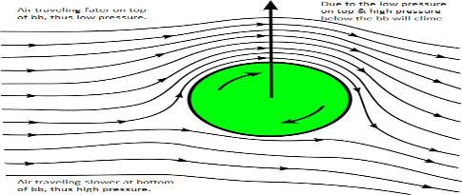
 | If $V_{A}<2U_{∞}⇒C_{L}<4π(2 St. Pt)$
 | If $V_{A}=2U_{∞}⇒C_{L}=4π(1 St. Pt)$
AEROFOILS: Stall Condition: $α>α_{@maxLift}$  Area $=LC$ Aspect Ratio $=L/C$ $L=$ Span $C=$ Chord  $α=$ Angle of Attack  At stall Condition, 1) BL Separation take place, 2) $C_{D}$ drastically increases  Circulation around an aerofoil, $Γ=πC U_{∞}\sin{α}$  Lift Force on aerofoil, $F_{L}=ρU_{∞}ΓL=π\sin{α}CLρU_{∞}^{2}$  For Aerofoil, $C_{L}=2π\sin{α}$ | 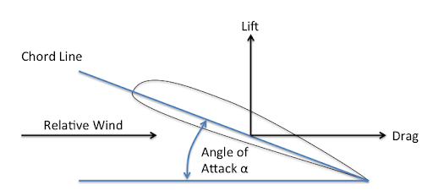

UNDER STEADY LIFT OF AEROPLANE:  In the Steady State Condition,  $$\sum{\vec{F }}=0$$  Forces Acting/Developed in the Aeroplane,  $F_{D}=$ Drag Force $F_{L}=$ Lift Force  $W=$ Weight of The Aeroplane $F_{T}=$ Thrust Developed by Aeroplane  Power Required to overcome Drag, $P_{D}=F_{D}U_{∞}$ | 